**For circular motion**

, 

**Newton’s second law**



**Friction**



**Resistive Force**

For low speeds

R = -bv

For high speeds

R = ½ DrAv2

**Work**



For varying force



**Force for a spring**

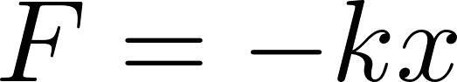

**For conservative force**

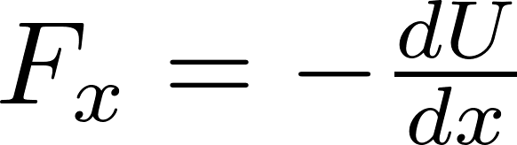

**Kinetic energy**

